**Hackathon Project Phases** for the **Recipe** **Blogging** project.

# Hackathon Project Phases

**Project Title:**

**Flavour Fusion: AI-Driven Recipe Blogging Using Gemini AI**

**Team Name:**

(Crew 04)

**Team Members:**

* Hyndhavi Goli
* Lalitesh Jangam
* Bhuvaneshwari Mopuri
* Pavan Kumar Kunchala

## Phase-1: Brainstorming & Ideation

**Objective:**

Develop an AI-powered recipe blogging expert tool using Gemini Flash.It creates a personalized experience for the user , showcases popular and trending recipes, and crestes a community through various recipe sharing services.

**Key Points:**

1. **Problem Statement:**

* 1. Many users struggle to find recipe’s using home ingredients,within a short period of time.

○ Users also need guidance on the dish and how certain quantity should be added for the recipes.

1. **Proposed Solution:**

* 1. An AI-powered application using **Gemini Flash** to provide **best recipes using few ingredients and within a short period of time.**

○ The app offers **tastes preferred by the user** and **also the type of food** that user preferences.

1. **Target Users:**

* **Students/bachelors** that prefer good food with few ingredients.

○ **Newly married couples** that need guidance in making recipes.

1. **Expected Outcome:**

* 1. A functional **AI-powered Recipe blogging app** that provides good recipes with in a short period of time.

## Phase-2: Requirement Analysis

**Objective:**

Define the technical and functional requirements for the AI driven – recipe blogging using Gemini ai.

**Key Points:**

1. **User Interfaces:**

* 1. Ingredients

○ Cuisine

○ Dish type

○ Dietary Restrictions

1. **Functional Requirements:**

* 1. Ability to generate step-by-step instructions.

○ Automatic measurement conversion(metric/imperial).

○ Substitutions for ingredients based on dietary restrictions (vegan, gluten-free, keto, etc).

○ Ai-powered variation suggestions (e.g , “make this spicy” or “try a healthier version”).

1. **Constraints & Challenges:**

* 1. AI requires diverse, high-quality datasets for accurate recipe generation, incomplete or biased datasets can lead to poor recommendations.

○ Handling high traffic and real time interactions requires robust cloud infrastructure.

○ AI-generated food images may not always look realistic or appealing.

## Phase-3: Project Design

**Objective:**

Develop the architecture and user flow of the application.

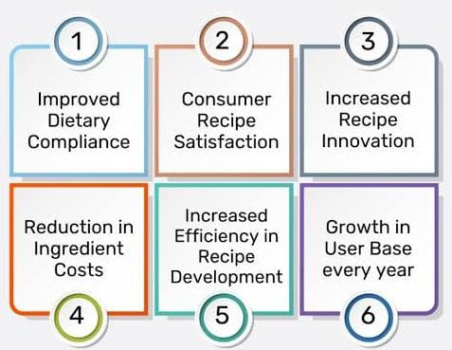

**Key Points:**

1. **System Architecture:**

* 1. Web-based or mobile-friendly blogging platform.

○ Dashboard for recipe creation, customization, and analytics.

1. **User Flow: 9+**

* 1. Step 1: User inputs ingredients, cuisine type, or dietary preference.

○ Step 2: AI generates a recipe with step-by-step instructions.

○ Step 3: System suggests variations and substitute`es.

1. **UI/UX Considerations:**

* 1. **Clean, minimalist Design: Avoid clutter with a focus on images and text readability.**

○ **Main Sections: Home, explore, create, my recipes, AI chat, settings.**

○ **Breadcrumbs & Search Bar: Help users find content quickly.**

## Phase-4: Project Planning (Agile Methodologies)

**Objective:**

Break down development tasks for efficient completion.

|  |  |  |  |  |  |
| --- | --- | --- | --- | --- | --- |
| Phase | Descripition | Tasks/Actions | Timeframe | Responsible/Team | Resources Needed |
| Ideation&concept | Defining the purpose.goals,and features of the AI-driven recipe blog | -identify target audience  -Define key funtionalities | 1 weeks | Product manager and team leads | Market research,idea generation tools |
| Market Research | Analylizing competitors,  Understanding  user needs. | -Research similar Ai-driven recipe blogs or apps | 2 weeks | Research team.  UX team | Competitor Analysis,surveys |
| AI Integration Design | Desiging the Ai system | -system AI model for recipie | 3 weeks | AI engineers, Data scientists | AI/ML models |
| Content strategy | Planning the content creation process for recipe and blog posts | -Devolop a content calender | 2 weeks | Content manager,writers | Content management Tools, SEO Tools |
| Web development | Building the platform | Select AI model for recipe generation | 3weeks | Web developers ,AI engineers | WebDevelopent frameworks, |
| Recipe database | Building or sourcing a recipe database for the AI to work | -Collect recipes data | 2 weeks | Data enginmeers , | Recipe data,API’s |

## Phase-5: Project Development

**Objective:**

Implement the AI driven – recipe blogging using Gemini ai.

**Key Points:**

1. **AI Recipe Blogging – Project Development Plan**

The development process follows an Agile Methodology with iterative sprints to ensure to ensure flexibility , continuous feedback, and improvements.

1. **Development Process:**

* 1. Agile Approach: Bi-weekly sprints with features releases.

○ Version Control: Git/GitHub for code management.

○ CI/CD Pipeline: Automate testing and deployment.

1. **Challenges & Fixes:**

* 1. **Challenge:** AI may generate unrealistic, incomplete, or incorrect recipes.

**Fix:** Implement a human validation process for AI-generated recipes.

## Final Submission

1. **Project** **Overview**:

The AI-Driven Recipe Blogging Platform aims to revolutionize the way users discover, generate, and interact with recipes. By leveraging AI technology, the platform allows users to input ingredients, dietary preferences, and other factors to generate personalized recipes. Additionally, it offers features like personalized recommendations, ingredient substitutions, and nutritional analysis, all while enabling content creators to share and engage with their audience.